**PERSON Table Values:**

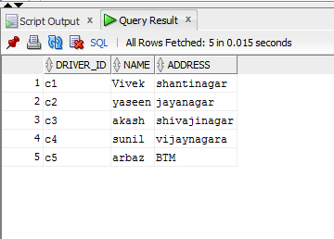

**CAR Table Values:**

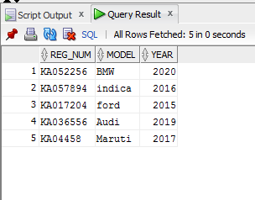

**ACCIDENT Table values:**

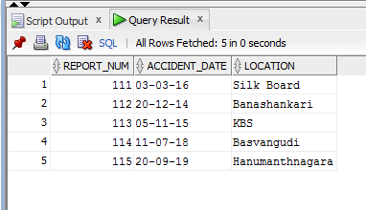

**OWNS Table Values:**

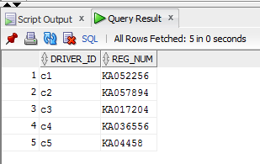

**PARTICIPATED Table Value:**

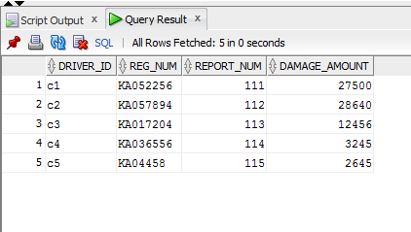

**Additional Queries:**

1) LIST THE ENTIRE PARTICIPATED RELATION IN THE DESCENDING ORDER OF DAMAGE AMOUNT.

**select * from participated**

**order by damage_amount;**

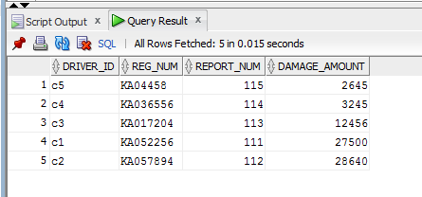

2) FIND THE AVERAGE DAMAGE AMOUNT

**select avg(damage_amount)**

**from participated;**

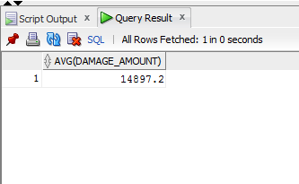

3) DELETE THE TUPLE WHOSE DAMAGE AMOUNT IS BELOW THE AVERAGE DAMAGE AMOUNT.

**delete from participated**

**where damage_amount < 14897.2;**

* **3 ROWS DELETED.**

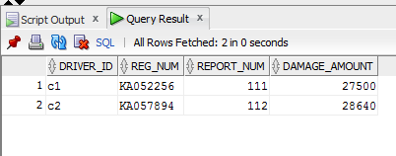

5) FIND MAXIMUM DAMAGE AMOUNT.

**select max(damage_amount)**

**from participated;**

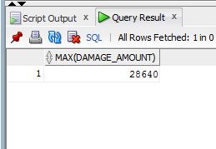

**Queries:**

1. **Update the damage amount to 25000 for the car with a specific reg_num (‘KA057894’) for which the accident report number was 112.**

**update participated**

**set damage_amount = 25000**

**where reg_num = 'KA057894' and report_num = 112;**

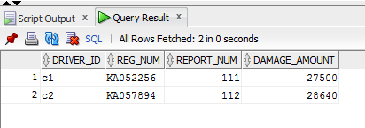

1. **Find the total number of people who owned cars that were involved in accidents in 2018.**

**select count(distinct driver_id) CNT from participated a, accident b where a.report_num=b.report_num and b.accident_date like '%14';**

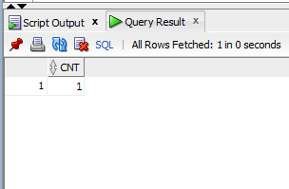

1. **Find the number of accidents in which cars belonging to a specific model (example 'BMW') were involved.**

**select count(report_num) CNT from car c,participated p where c.reg_num=p.reg_num and model='BMW';**

